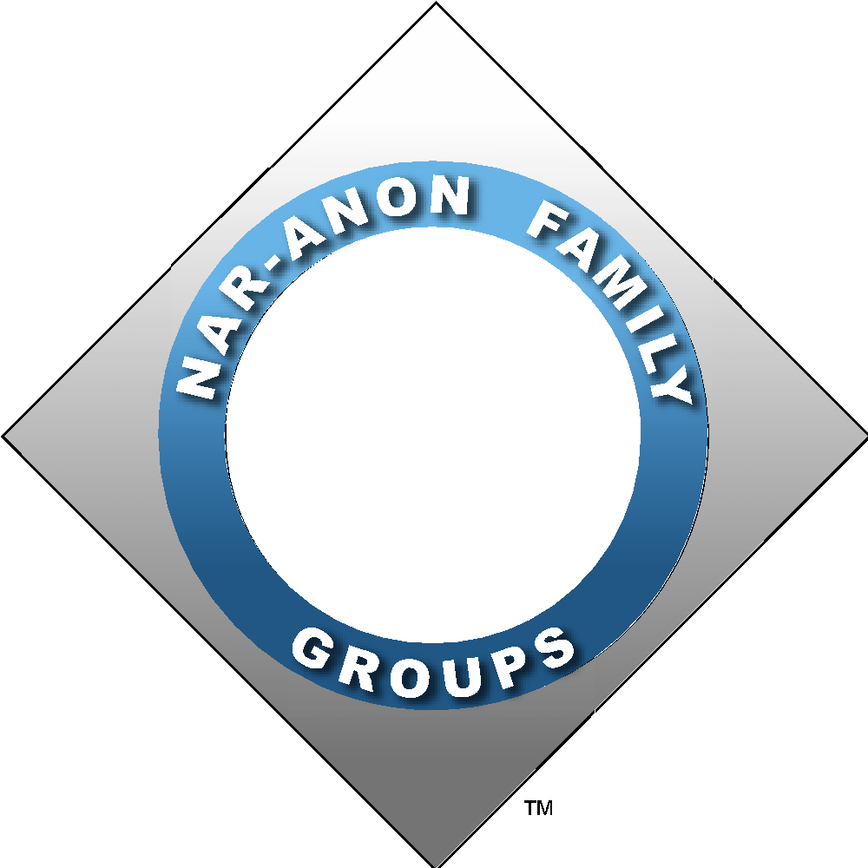 Midwest Region of Nar-Anon Family Groups

Tis the Season to pick up some recovery tools as you go into the Holidays…
A tool, by design, makes efforts more productive
Pick a few to take with you wherever you go

- Go into the holidays Keeping It Simple.
- Be mindful that I am powerless over my addict, my family and all other people.
- Duct tape. More listening, less talking.
- Take a risk with intimacy. Nothing changes if nothing changes, let it begin with me.
- Ask for what I need.
- Don’t pray for solutions. Pray for release from fear, anxiety and pain inflicted by others.
- Don’t fall into the habit of thinking joy is an indulgence. Create. Make. Go. Do. Have adventures.
- I am worth the time, effort and expense to take care of myself.
- Recognize and attend to H.A.L.T. Hungry Angry Lonely Tired.
- Be still. The world is loud but my Higher Power speaks in whispers.
- Stash my favorite slogan somewhere on my person so I can touch it, read it.
- Mind my Ps and Qs.
Qs: Question when I feel fear, anxiety, stress, misplaced responsibility- clues that I need to return my focus to what is going on with me. Is this mine?
Ps: Pause, Pray, Proceed- What is the next right thing for me right now?
How do I pray for or support others? Pray for Peace in mind and body, Perseverance, and the Presence of their HP with them.
- Practice Acceptance. Live and Let Live. Love and Let Be.
- Reach out. Accept humanity and compassion from others. Phone or text a friend.
- Set a timer. There is a time to be alone and time to be with others. Scheduling short alone time breaks and leaving before I’m exhausted are good choices for me.
- Recognize and be grateful for a spiritual awakening happening in me when I begin to see from a different perspective.
- Pick a step that speaks to my needs and circumstances and ask my HP to help me use it.
- The Serenity Prayer works! Keep accepting, moving and seeking.
- Shed the “Holiday Creator Cape.” It doesn’t belong to me. I can participate in the small beautiful moments that I enjoy and let others find their own happy place in this holiday season. Celebrations are “we” events. It is not all my responsibility to do everything for everyone. I will breathe, and do my part, and go with the flow. It will be what it will be. Different may be a pleasant surprise.
- Remember recovery is not about surviving addiction. Recovery is about becoming a better person, in thought, word and deed. Be the change you want to see in the world.
All our best to you and yours, Ruth and Theresa, 2016

