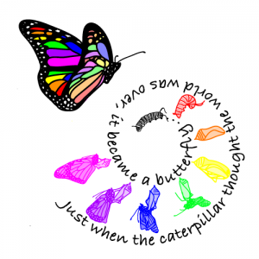
12 STEPS WORKSHOP

Recovery
Insight
Transformation
Joy
One Step at a Time
Choosing to work the Steps is a life affirming decision! It can be a transformative and spiritual process - an awakening of sorts. There is a reason why we say, "It works if you work it!"
We have our own narrative, and this process allows us the opportunity to view ourselves more clearly, to rid ourselves of those things in our story that are harmful to our spirit, celebrate the person we are in this moment and strengthen those traits that help us be the person we want to be.
In a caring and open environment, we can gain insight from each other. We can learn to trust fully and feel safe enough to open our hearts.
- Meetings: Tuesday’s from 7-8:30 and Sunday’s from 4-5:30 central time
- Start dates: October 4th and October 9th
- Location: Zoom meeting invite will be sent to responders – pls rsvp by 10/1
- Facilitator: Maureen R. – 6th year of facilitating
- Meetings
- Cost is $60 for supplies. Scholarships are available if needed
- Space is limited to 8-10 max
- Questions? Please do contact Maureen at 314-578-5630 or kmadkins@msn.com
OUR JOURNEY BEGINS WITH THE FIRST STEP!

